**Supplementary Figures**

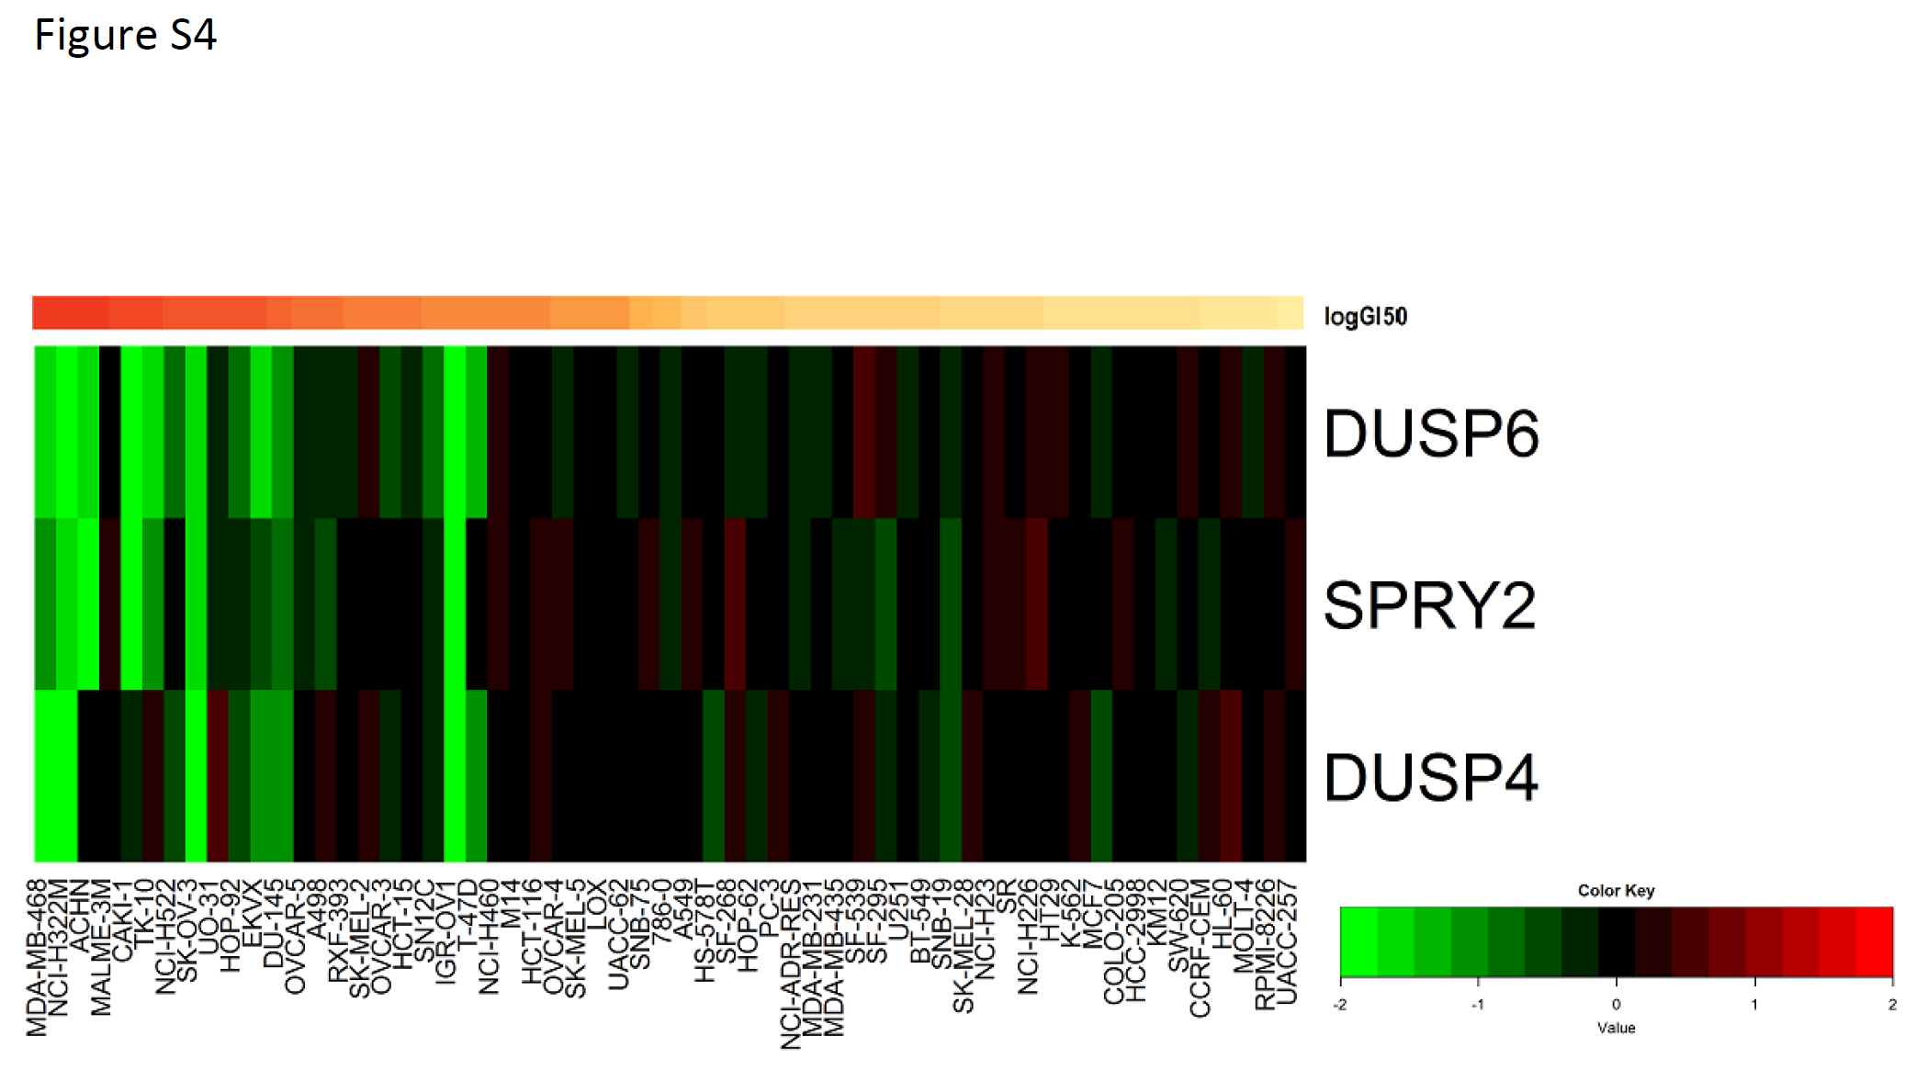

**Supplementary Figure S1:** Correlation between downregulation of EGFR transcriptional target genes, and sensitivity to erlotinib at the high concentration after 6 hours. Heat map shows expression changes in 3 genes with the NCI‑60 cell lines ordered according to the level of their sensitivity (logGI50) to erlotinib, from the most sensitive cell lines on the left to the most resistant on the right.

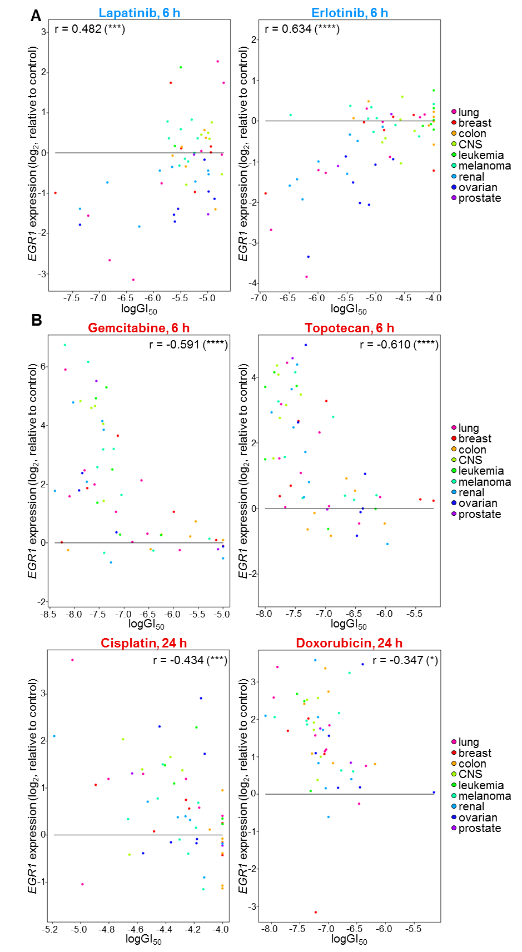

**Supplementary Figure S2:** EGFR inhibitors and DNA damaging agents induce directionally opposing changes in *EGR1* expression that are differentially associated with drug sensitivity. LogGI50 values and *EGR1* expression levels upon drug exposure to the indicated EGFR inhibitors (blue) or DNA damaging agents (red) for the indicated treatment times are shown for each of the NCI-60 cell lines. Correlation coefficients and corresponding p-values from Pearson correlation analyses are shown (\**P* < 0.05; \*\*\**P* < 0.001; \*\*\*\**P*< 0.0001). Colors representing the tumor tissue derivation of each cell line are as indicated.

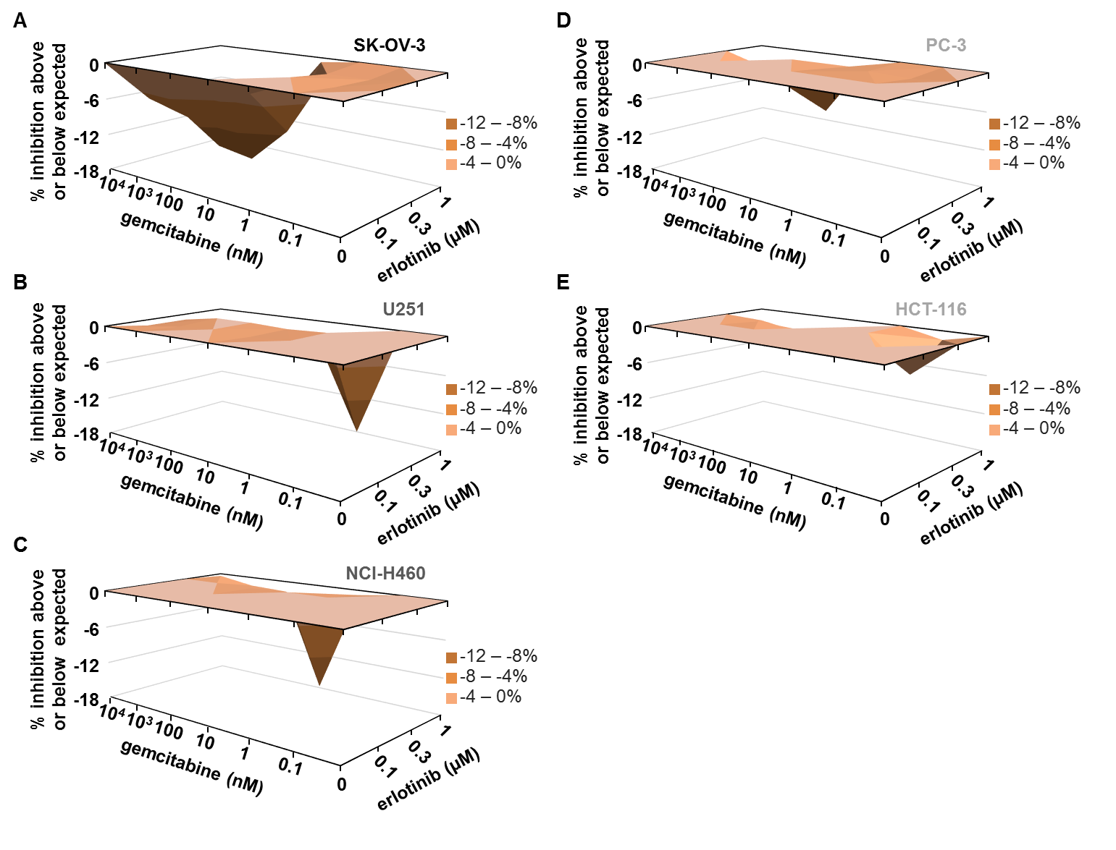**Supplementary Figure S3:** Representative 3D response surface plots for the gemcitabine-erlotinib combination in the indicated cell lines. Response surface analyses were performed based on the MacSynergy II model. Average antagonism volumes from 3D plots for 2-3 replicate experiments in each cell line are shown in Figure 4C.

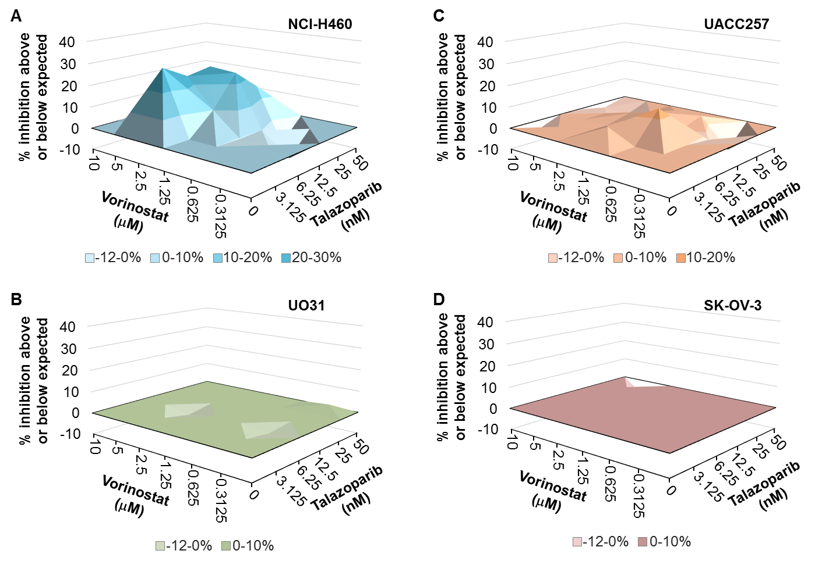

**Supplementary Figure S4:** Representative 3D response surface plots for the sequential vorinostat-talazoparib combination in the indicated cell lines. Response surface analyses were performed based on the MacSynergy II model. Average synergism volumes from 3D plots for 2‑3 replicate experiments in each cell line are shown in Figure 5C.

**Supplementary Tables**

|  |  |  |  |
| --- | --- | --- | --- |
| **Gene** | **Correlation coefficient** | **Gene** | **Correlation coefficient** |
| *ATF3* | 0.814 | *KIF20A* | 0.787 |
| *BTG1* | 0.572 | *LMNB1* | 0.775 |
| *C12ORF34* | 0.668 | *MARS2* | 0.231 |
| *C5orf41* | 0.711 | *MGEA5* | 0.159 |
| *CCNB1* | 0.528 | *MXD1* | 0.816 |
| *CCNF* | 0.645 | *NRF1* | 0.478 |
| *CCNG2* | 0.751 | *PLK1* | 0.822 |
| *CDKN1A* | 0.741 | *PNRC1* | 0.372 |
| *CLK1* | 0.622 | *PSRC1* | 0.823 |
| *DDIT3* | 0.732 | *RRS1* | 0.456 |
| *DNAJB9* | 0.783 | *SAT1* | 0.726 |
| *G2E3* | 0.493 | *SESN2* | 0.655 |
| *GARAPAPL1* | 0.875 | *SKP2* | 0.431 |
| *HBP1* | 0.728 | *YPEL* | 0.808 |

**Supplementary Table S1:** Validation of array-based measurements by qRT-PCR. This table shows the correlation between gene expression measured from the array-based expression analyses in NCI TPW and the same genes measured independently using Fluidigm expression analysis. Up to 60 cell lines were treated independently with 6 drugs for 24 hours to generate the samples for high throughput qPCR Fluidigm analysis. Cell line subsets for these experiments were selected to encompass a broad range of sensitivities to the agents tested. The 19 cell lines in subset A (see below) were treated for 24 hours with high concentrations of bortezomib, doxorubicin, sunitinib, sirolimus, dasatinib, or high or low concentrations of paclitaxel. In a second experiment to examine the most and least gene-activating agents across additional cell lines, the 27 cell lines in subset B (see below) were treated for 24 hours with high concentrations of bortezomib (the most gene-activating drug) or doxorubicin (control) or low concentration of paclitaxel (the least gene-activating drug).

Cell line subset A: ACHN, CAKI‑1, CCRF-CEM, DU145, EKVX, HOP‑62, HT29, IGR‑OV1, LOX IMVI, MCF7, MDA‑MB‑231, MDA-MB-468, OVCAR-3, OVCAR‑5, PC‑3, SK‑OV‑3, SN12C, UO-31, UACC‑62

Cell line subset B: 786-O, A498, A549, BT‑549, NCI‑H460, NCI‑H522, HCT‑116, HCT‑15, HL‑60, HOP‑92, HS 578T, K‑562, KM12, M14, OVCAR‑4, OVCAR‑8, RPMI‑8226, SF‑268, SF‑295, SF‑539, SK‑MEL‑2, SK‑MEL‑5, SNB‑19, SW‑620, TK‑10, U251, UACC‑257

|  |  |
| --- | --- |
| **Pathway Function** | **Genes in each pathway** |
| MAPK | *AURKA, AURKB, SON, CENPA, KIF11, DUSP6, TPX2* and *EGR1* gene expression to represent the by-product of Erk1/2 phosphorylation and subsequent translocation to the nucleus as a result of pathway activation (1-3) |
| AKT/PI3K | *CFLAR, XIAP, BIRC5, BIRC3, GADD45A, MCL1, BCL2, BCL2L1, HIF1A, AP1, AR, STAT3, IL6* and *VEGF* gene expression was used to represent the activation of transcription factors such as Jun and Fos, leading to the increase in expression of these target genes (4-6) |
| Cell Cycle Checkpoint | *CHEK1, CHEK2, TP53, MDM2, CDKN1A, CCNE1, CDK2, CDC25a, SMC1, CCNB1, CDK1, CDC25b, CDC25c, PLK1, WEE1* and *CCND1* gene expression was used to represent the activation of the cell cycle and checkpoint proteins which maintain control of this process (6-9) |
| JAK/STAT | *SOCS1, NMI, BCL2L1, CDKN1A* and *MYC* gene expression were used to represent the activation of transcription factors such as NP-1 and STAT, leading to the increase in expression of these target genes (6,10) |
| Immunity Related | *PTGS, BCL2L1, XIAP, BIRC5, CFLAR, IL-6, IL1b* and *TNF* gene expression were used to represent the activity of the cell initiating an immune response (10-12) |
| DNA  Repair | *XRCC6, PRKDC, DCLRE1C, NHEJ1, XRCC4, LIG4, BRCA1, RAD52, BRCA2, RAD54L, ATM, ATR* and *PARP1* gene expression were used to represent the cells response to DNA damage and repair mechanisms (9,13,14) |
| DNA Damage: Apoptotic Response | *TP53, FAS, BBC3, BAX, PMAIP1* and *PARG* gene expression were used to represent the cells response to excessive DNA damage leading to an apoptotic response (13-15) |
| ER Stress: Survival | *HSPA5, HSP90B1, XBP1, P4HB, ATF4* and *GADD45A* gene expression were used to represent the cells activation of an ER Stress response (16) |
| ER Stress: Apoptotic Response | *ATF3, DDIT3, TNFRSF10B, TRIB3, BCL2L11, BBC3, CASP2* and *GADD34* gene expression were used to signify the ER Stress pathway activation leading to an Apoptotic response in the cell (16-19) |
| Apoptosis: Extrinsic Activation | *BID, FAS, BCL2L11, CASP8, CASP9* and *APAF1* gene expression were used to imply the activity of the extrinsic activation of the apoptotic response (4,20-22) |
| Apoptosis: Intrinsic Activation | *BAX, BAK1, BID, PMAIP1, BBC3, CASP6, CASP9* and *APAF1* gene expression were used to imply the activity of the intrinsic activation of the apoptotic response (4,20-22) |
| Autophagy: Recycling/ Starvation | *MAP1LC3B, ULK1, ATG13, BECN1, SQSTM1, ATG5, ATG12* and *CTSB* gene expression were used to signify the activation of the autophagic response a cell elicits during times of depleted nutrients (23-25) |
| Autophagy: Toxic | *SQSTM1, ATG7, RIPK1* and *CTSB* gene expression were used to signify the process in which autophagy induces cell death (23-25) |

**Supplementary Table S2:** For the heatmap analysis of transcriptional response, a gene list was generated using information about cell signaling pathways and published data supporting the downstream targets of the 13 specific pathways and processes examined in this study (see Supplemental References, below).

| **Gene** | **Drug tested** | | | | | | | | | | | | | | |
| --- | --- | --- | --- | --- | --- | --- | --- | --- | --- | --- | --- | --- | --- | --- | --- |
| **A** | **B** | **C** | **DA** | **DO** | **E** | **GEL** | **GEM** | **L** | **P** | **SI** | **SO** | **SU** | **T** | **V** |
| HLA-E | H*  L | H*  L* | H*  L | H*  L* | H† L* | H* L | H* L* | H* L* | H* L* | H  L | H  L | H* L* | H* | H*  L | H* L* |
| HLA-G | H  L | H* L* | H | H L | H* L | H | H | H L | H L | L | H L | H L | H | H* | H*  L* |
| BTG1 | H†  L* | H† L† | H* L | H† L* | H‡ L* | H* | H* | H† L† | H* | H* L* | H  L | H† L* | H* | H† L | H† L* |
| CD55 | H†  L* | H‡ L‡ | H* | H‡ L† | H† L* | H* | H* | H* L* | H† | L* | H* L* | H† L† | H | H* | H† L* |
| MAP1LC3B | H* L* | H† L† | H* | H* L* | H† L* | H* | H* L* | H* L* | H* L | H* L | H* L* | H† L* | H* | H* | H*  L* |
| HIST1H4C | H*  L | H† L† | H* | H* L* | H* L* | H* | H* L* | H* L* | H* | H‡ L‡ | H* | H† L* | H* | H† L* | H‡ L* |
| XRCC5 | H | H* L* | H | H* L | H* | H | H L | H*  L | H | H  L | H L | H*  L | H | H*  L | H*  L |
| SLC19A1 | H L | H*  L* | H | H* L | H* L* | H | H* L* | H* L | H* | L | H L | H* L* | H* | H* | H* L* |

A: azacytidine, B: bortezomib, C: cisplatin, DA dasatinib, DO: doxorubicin, E: erlotinib, GEL: geldanamycin, GEM, gemcitabine, L: lapatinib, P: paclitaxel, SI: sirolimus, SO, sorafenib, SU: sunitinib, T: topotecan, V: vorinostat.

**Supplementary Table S3:** Genes with concerted change in the same direction (upregulation or downregulation) 24 hours after treatment with each of the 15 drugs. Shown are the direction and the magnitude of expression changes among the five upregulated genes (red font) and the three genes (blue font) downregulated by all agents. Concerted changes in expression are listed for microarray experiments in which nearly all cell lines had a change in the same direction, with no more than 15 cell lines showing a change in the opposite direction. H: changes were measured at the high drug concentration; L: changes were measured at the low drug concentration.

* |**∆** fold change| (the magnitude of the difference of log2 expression values between treated and untreated cells) in that direction in at least one cell line was > 1.

† |**∆** fold change| in that direction in at least one cell line was > 2.5.

‡ |**∆** fold change| in that direction in at least one cell lines was > 4.

| **Drug** | **Gene** | | **Condition** | **∆ fold change analysis** | | **Correlation analysis (∆ fold change vs. logGI50)** | |
| --- | --- | --- | --- | --- | --- | --- | --- |
|
| **Mean ∆ fold change in least sensitive lines** | **Mean ∆ fold change in most sensitive lines** | ***r*** | ***p*-value1** |
|
|  |
| Bortezomib |  | *TNFRSF1A* | High 24 h | -1.20 | -0.02 | -0.40 | 0.017 |
|  | *NACC2* | High 6 h | -1.18 | -0.48 | -0.41 | 0.016 |
|  | *ALDH3A1* | High 24 h | -1.15 | -0.07 | -0.36 | 0.036 |
|  | *ZNF239* | High 24 h | -1.05 | -0.06 | -0.40 | 0.018 |
|  | *ALDH3A1* | Low 24 h | -1.02 | -0.03 | -0.39 | 0.017 |
|  | *NAP1L2* | High 6 h | 1.00 | 0.11 | 0.41 | 0.016 |
|  | *SLC38A6* | Low 24 h | 1.10 | -0.02 | 0.40 | 0.016 |
|  | *CTSD* | Low 24 h | 1.19 | 0.35 | 0.33 | 0.044 |
|  | *GFPT2* | High 24 h | 1.20 | 0.43 | 0.33 | 0.048 |
|  | *SAT1* | High 6 h | 1.22 | 0.40 | 0.35 | 0.037 |
| Geldanamycin | * | *DACT1* | High 24 h | -1.27 | -0.16 | -0.47 | 0.013 |
|  | *TRIB2* | High 24 h | -1.21 | -0.20 | -0.43 | 0.015 |
|  | *SCG5* | High 24 h | -1.20 | 0.04 | -0.33 | 0.048 |
| * | *TNFAIP3* | High 24 h | -1.19 | -0.32 | -0.43 | 0.015 |
|  | *NLGN1* | High 24 h | 1.01 | 0.13 | 0.39 | 0.018 |
|  | *PPP1R3C* | High 24 h | 1.05 | 0.09 | 0.38 | 0.021 |
|  | *PDZD2* | High 6 h | 1.07 | 0.08 | 0.45 | 0.013 |
| Gemcitabine |  | *H1F0* | High 24 h | -1.29 | -0.40 | -0.34 | 0.040 |
|  | *PSMB9* | High 24 h | 1.05 | 0.32 | 0.52 | 0.005 |
|  | *CLIC3* | High 24 h | 1.06 | 0.30 | 0.40 | 0.017 |
|  | *CTSL2* | High 24 h | 1.20 | 0.21 | 0.45 | 0.013 |
| Sorafenib |  | *MICAL2* | High 24 h | 1.04 | 0.40 | 0.40 | 0.017 |
| Topotecan |  | *MYO1D* | High 24 h | -1.12 | -0.31 | -0.40 | 0.016 |
| * | *TGFBR3* | High 24 h | -1.08 | 0.01 | -0.43 | 0.015 |
| * | *RPS6KA2* | High 24 h | -1.02 | -0.27 | -0.38 | 0.021 |
|  | *FSCN1* | High 24 h | 1.00 | 0.14 | 0.39 | 0.017 |
|  | *HPSE* | High 24 h | 1.10 | 0.24 | 0.44 | 0.013 |
|  | *CPA4* | High 24 h | 1.24 | 0.07 | 0.35 | 0.032 |
|  | *APOBEC3B* | High 24 h | 1.32 | -0.05 | 0.40 | 0.016 |
| Vorinostat | * | *ZIC1* | High 24 h | -1.39 | 0.09 | -0.44 | 0.013 |
|  | *CCL2* | High 6 h | -1.29 | -0.04 | -0.36 | 0.028 |
|  | *RCBTB2* | Low 24 h | -1.17 | -0.39 | -0.36 | 0.027 |
|  | *TDP1* | High 24 h | -1.09 | -0.35 | -0.34 | 0.040 |
|  | *TNFAIP6* | High 6 h | 1.07 | 0.22 | 0.33 | 0.046 |
|  | *C1orf116* | High 24 h | 1.09 | 0.23 | 0.34 | 0.037 |
|  | *HMOX1* | High 6 h | 1.23 | 0.41 | 0.37 | 0.027 |
|  | *NAP1L3* | High 24 h | 1.98 | 0.31 | 0.34 | 0.037 |

**Supplementary Table S4**. Selected genes potentially mediating drug insensitivity to agents in the NCI TPW dataset. Each **∆** fold change value is the difference in log2 expression values between treated and untreated cells. Shown are genes exhibiting strong changes in expression (mean |**∆** fold change| ≥ 1) in the 25% least sensitive cell lines and weak changes (mean |**∆** fold change| ≤ 0.5) in the 25% most sensitive cell lines and for which **∆** fold change is significantly correlated with GI50 according to Pearson's correlation analysis across all NCI-60 cell lines. For gene-drug pairs in which multiple time points or drug concentrations met the aforementioned criteria, only the time point and drug concentration yielding the largest-magnitude *r* value is shown.

*tumor suppressor gene (https://bioinfo.uth.edu/TSGene/coding_tsg.cgi)

1All *p*-values have been adjusted for multiple testing using the Benjamini and Hochberg method of adjustment for false discovery rate (*J R Stat Soc Series B Stat Methodol* 1995, 57: 289-300).

# Supplemental References (for Supplementary Table S2)

1. Furukawa T. Impacts of activation of the mitogen-activated protein kinase pathway in pancreatic cancer. Front Oncol 2015;**5**:23.

2. Johnson GL, Lapadat R. Mitogen-activated protein kinase pathways mediated by ERK, JNK, and p38 protein kinases. Science 2002;**298**:1911-2.

3. Neuzillet C, Hammel P, Tijeras-Raballand A, Couvelard A, Raymond E. Targeting the Ras–ERK pathway in pancreatic adenocarcinoma. Cancer Metastasis Rev 2013;**32**:147-62.

4. Benn SC, Woolf CJ. Adult neuron survival strategies-slamming on the brakes. Nat Rev Neurosci 2004;**5**:686-700.

5. Mei L, Xiong W-C. Neuregulin 1 in neural development, synaptic plasticity and schizophrenia. Nat Rev Neurosci 2008;**9**:437-52.

6. Huang Y, de Reyniès A, de Leval L, Ghazi B, Martin-Garcia N, Travert M*, et al.* Gene expression profiling identifies emerging oncogenic pathways operating in extranodal NK/T-cell lymphoma, nasal type. Blood 2010;**115**:1226-37.

7. Schadendorf D, Fisher DE, Garbe C, Gershenwald JE, Grob JJ, Halpern A*, et al.* Melanoma. Nat Rev Dis Primers 2015;**1**:15003.

8. Bieging KT, Mello SS, Attardi LD. Unravelling mechanisms of p53-mediated tumour suppression. Nat Rev Cancer 2014;**14**:359-70.

9. Hu H, Gatti RA. MicroRNAs: new players in the DNA damage response. J Mol Cell Biol 2011;**3**:151-8.

10. Rawlings JS, Rosler KM, Harrison DA. The JAK/STAT signaling pathway. J Cell Sci 2004;**117**:1281-3.

11. Gaestel M, Kotlyarov A, Kracht M. Targeting innate immunity protein kinase signalling in inflammation. Nat Rev Drug Discov 2009;**8**:480-99.

12. Wright CJ, Kirpalani H. Targeting inflammation to prevent bronchopulmonary dysplasia: can new insights be translated into therapies? Pediatrics 2011;**128**:111-26.

13. Agarwal A, Mahfouz RZ, Sharma RK, Sarkar O, Mangrola D, Mathur PP. Potential biological role of poly (ADP-ribose) polymerase (PARP) in male gametes. Reprod Biol Endocrinol 2009;**7**:143.

14. Yoshiyama K, Sakaguchi K, Kimura S. DNA damage response in plants: conserved and variable response compared to animals. Biology 2013;**2**:1338-56.

15. Roos WP, Thomas AD, Kaina B. DNA damage and the balance between survival and death in cancer biology. Nat Rev Cancer 2016;**16**:20-33.

16. Rozpedek W, Pytel D, Mucha B, Leszczynska H, Diehl JA, Majsterek I. The role of the PERK/eIF2a/ATF4/CHOP signaling pathway in tumor progression during endoplasmic reticulum stress. Curr Mol Med 2016;**16**:533-44.

17. Hetz C, Mollereau B. Disturbance of endoplasmic reticulum proteostasis in neurodegenerative diseases. Nat Rev Neurosci 2014;**15**:233-49.

18. Ryoo HD. Long and short (timeframe) of endoplasmic reticulum stress-induced cell death. FEBS J 2016;**283**:3718-22.

19. Kadowaki H, Nishitoh H. Signaling pathways from the endoplasmic reticulum and their roles in disease. Genes 2013;**4**:306-33.

20. Remillard CV, Yuan JX-J. Activation of K+channels: an essential pathway in programmed cell death. Am J Physiol Lung Cell Mol Physiol 2004;**286**:L49-L67.

21. Galluzzi L, Blomgren K, Kroemer G. Mitochondrial membrane permeabilization in neuronal injury. Nat Rev Neurosci 2009;**10**:481-94.

22. Vucic D, Dixit VM, Wertz IE. Ubiquitylation in apoptosis: a post-translational modification at the edge of life and death. Nat Rev Mol Cell Biol 2011;**12**:439-52.

23. Galluzzi L, Bravo-San Pedro JM, Blomgren K, Kroemer G. Autophagy in acute brain injury. Nat Rev Neurosci 2016;**17**:467-84.

24. Marino G, Niso-Santano M, Baehrecke EH, Kroemer G. Self-consumption: the interplay of autophagy and apoptosis. Nat Rev Mol Cell Biol 2014;**15**:81-94.

25. Fuchs Y, Steller H. Live to die another way: modes of programmed cell death and the signals emanating from dying cells. Nat Rev Mol Cell Biol 2015;**16**:329-44.